Test Scenario | Test Case | Test Data | Expected Result | Actual Result | Pass/Fail
1.Error Handling | a. Invalid Date entered (invalid month number, rest of form blank, when saving) | See Image 1a | Display Error Message 004 | Displayed Error Message 004 | Pass
 | b. Invalid Date entered (without /, claim in last 5 years = Yes, rest of form blank, when saving) | See Image 1b | Display Error Message 004 | Displayed Error Message 004 | Pass
 | c. Invalid Mileage entered (letters, valid date entered, rest of form blank, when saving) | See Image 1c | Display Error Message 005 | Displayed Error Message 005 | Pass
 | d. Invalid Mileage entered (comma, 2 decimals, valid date entered, rest of form blank, when saving) | See Image 1d | Display Error Message 005 | Displayed Error Message 005 | Pass
 | e. Invalid Mileage entered (comma, 1 decimal, valid date entered, rest of form blank, when saving) | See Image 1e | Display Error Message 005 | Displayed Error Message 005 | Pass
 | f. Invalid Mileage entered (dot, 2 decimals, valid date entered, rest of form blank, when saving) | See Image 1f | Display Error Message 005 | Displayed Error Message 005 | Pass
 | g. Invalid Mileage entered (dot, 1 decimal, valid date entered, rest of form blank, when saving) | See Image 1g | Display Error Message 005 | Displayed Error Message 005 | Pass
 | h. Invalid Mileage entered (alphanumerical, valid date entered, rest of form blank, when saving) | See Image 1h | Display Error Message 005 | Displayed Error Message 005 | Pass
 | i. Invalid Registration Year entered (future year, valid date entered, rest of form blank, when saving) | See Image 1i | Display Error Message 008 | Displayed Error Message 013 | Fail
 | j. Invalid Registration Year entered (year negative number, completed form, when saving) | See Image 1j | Display Error Message 008 | File saved | Fail
 | k. Invalid Registration Year entered (year blank, completed form, rest of form blank, when saving) | See Image 1k | Display Error Message 008 | Displayed Error Message 008 but with Error Code 014 | Fail
 | l. Registration number must be entered (blank, rest of form blank, when saving) | See Image1l | Display Error Message 013 | Display Error Message 013 | Pass
 | m. Registration number must be entered (just numbers, rest of form blank, when saving) | See Image 1m.1, 1m.2 and 1m.3 | Display Error Message 013 | “Do you want to print the quote?” displayed, then Display Error Message 004, then Displayed Error Message 007 | Fail
 | n. Registration number must be entered (just letters, valid date entered, valid estimated annual mileage, rest of form blank, when saving) | See Image 1n.1 and 1n.2 | Display Error Message 013 | “Do you want to print the quote?” displayed, then Displayed Error Message 004 | Fail
 | o. Registration number must be entered (regular registration number, rest of form blank, when saving) | See Image 1o.1 and 1o.2 | Saves without errors | Displayed Error Message 004, then Displayed Error Message 007“ | Fail

Evidence

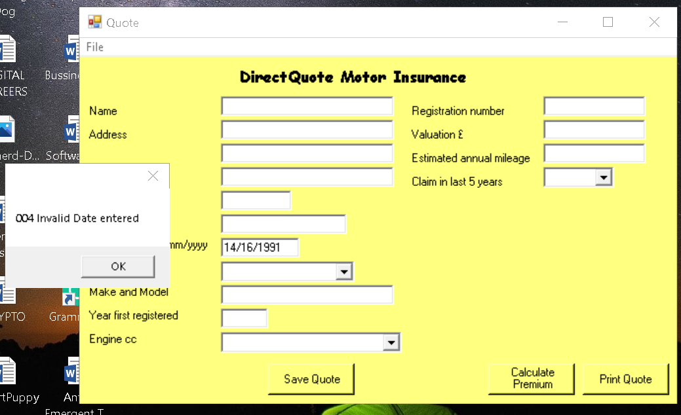1a
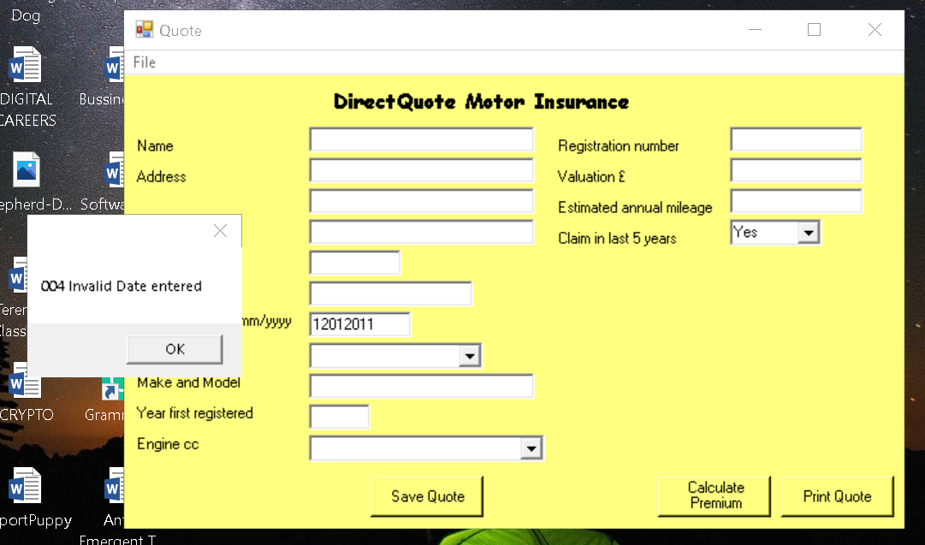1b
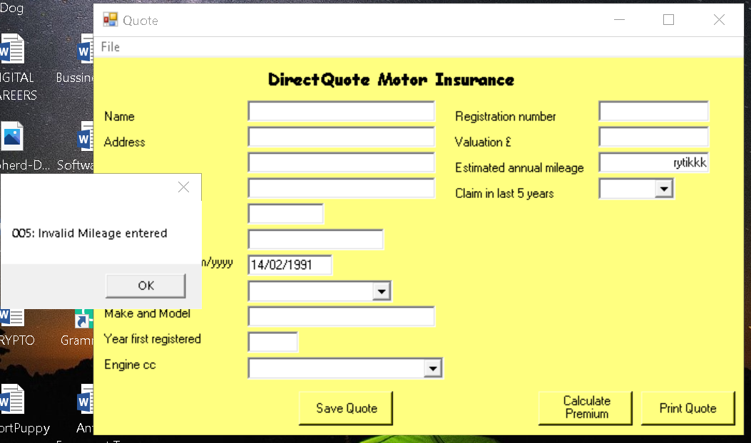1c

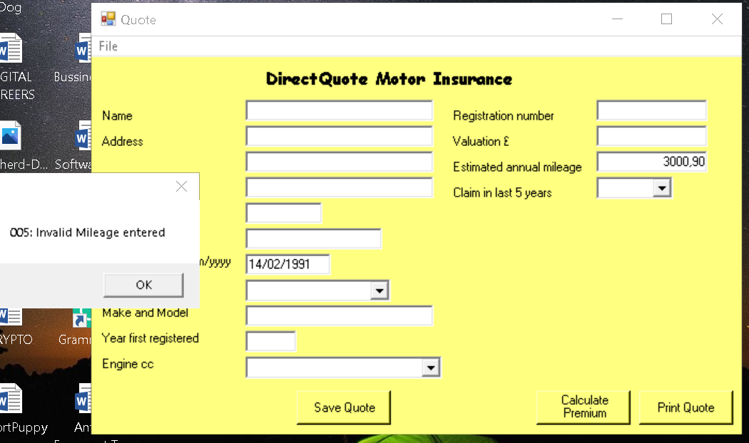1d
1e

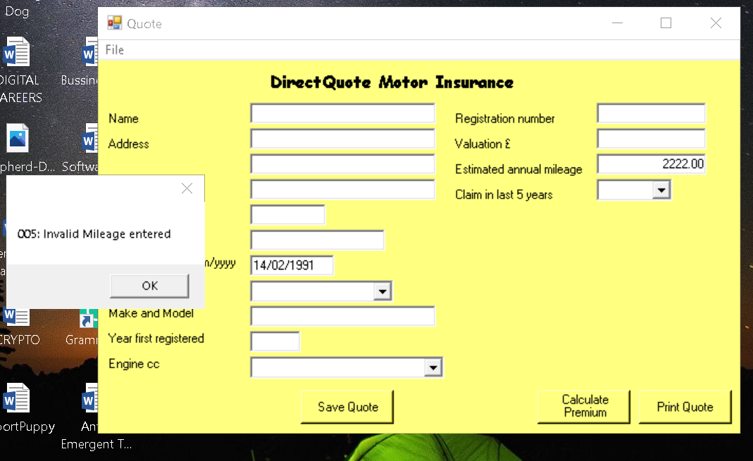1f
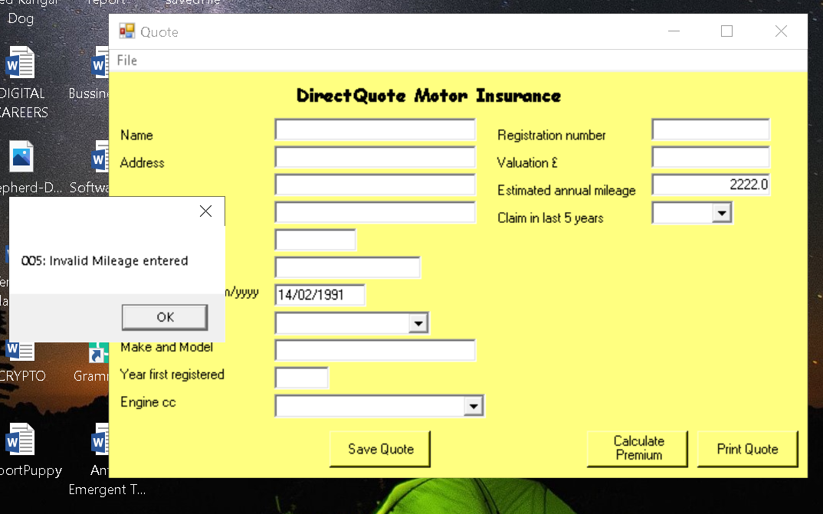1g

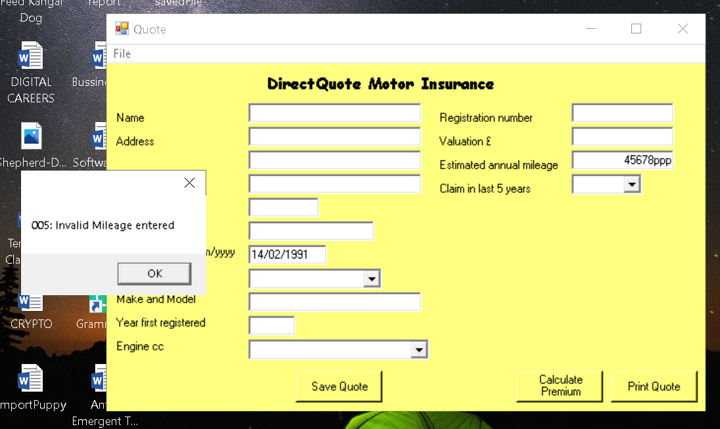1h

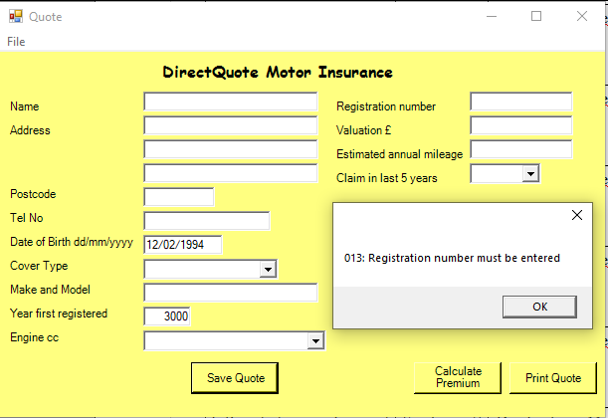1i
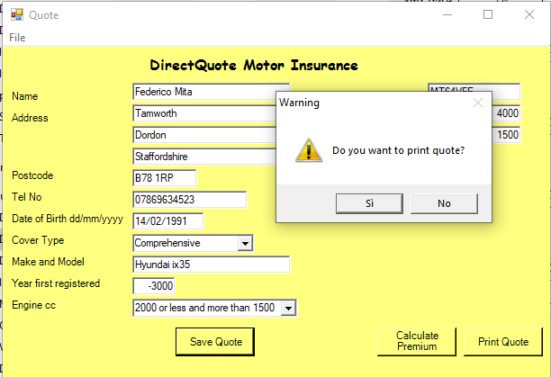1j1

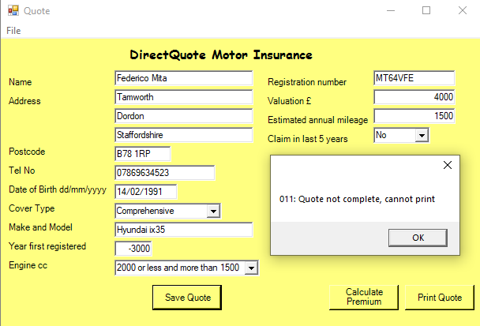1j.2

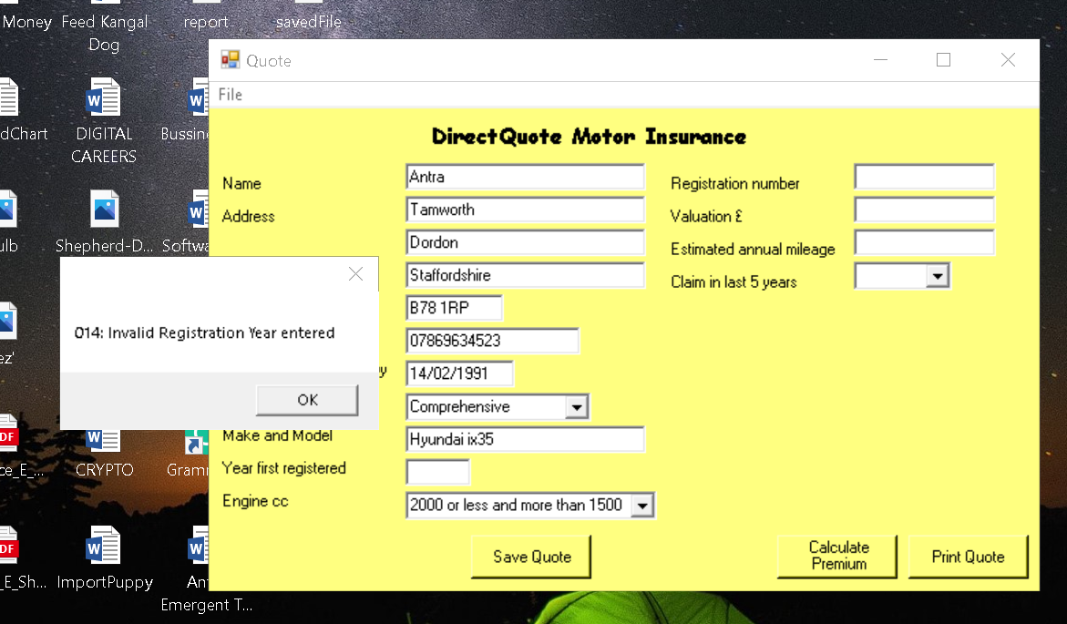1k

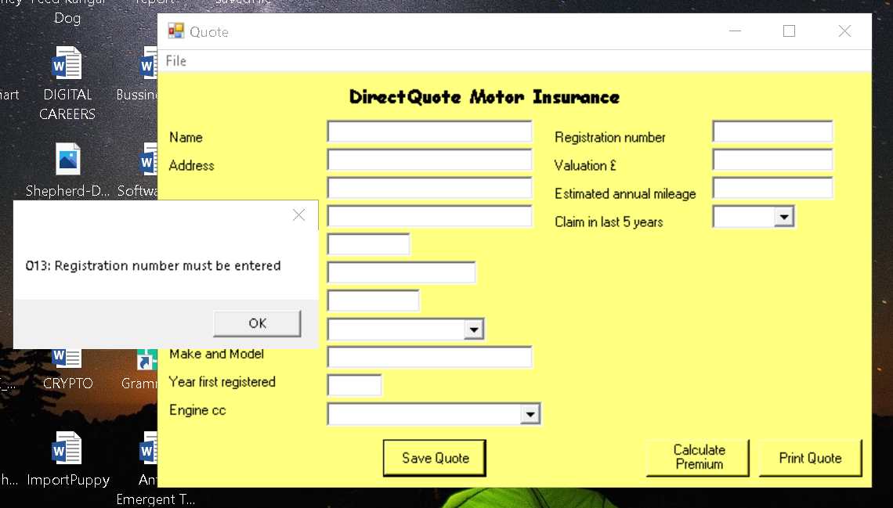1l
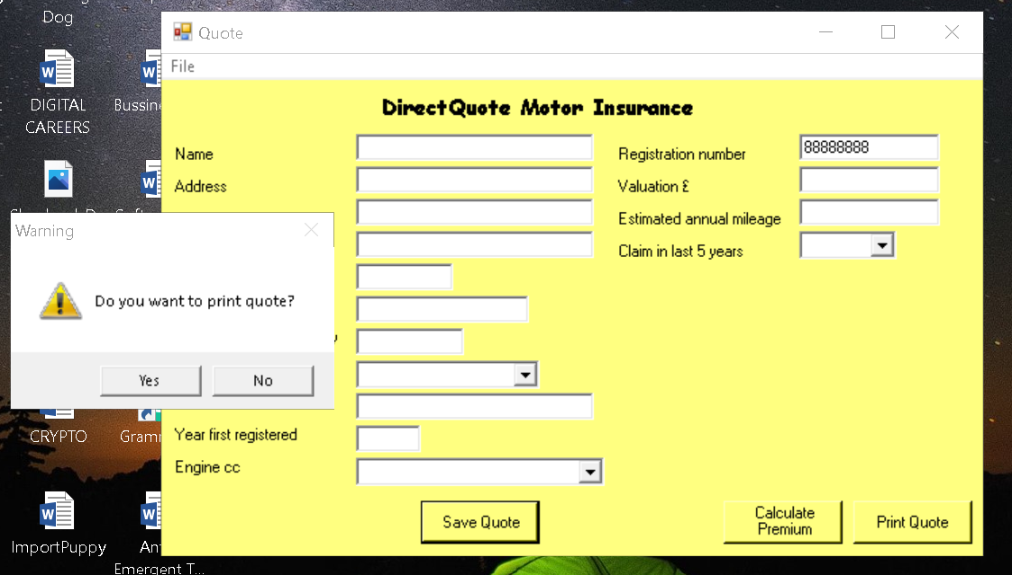1m.1

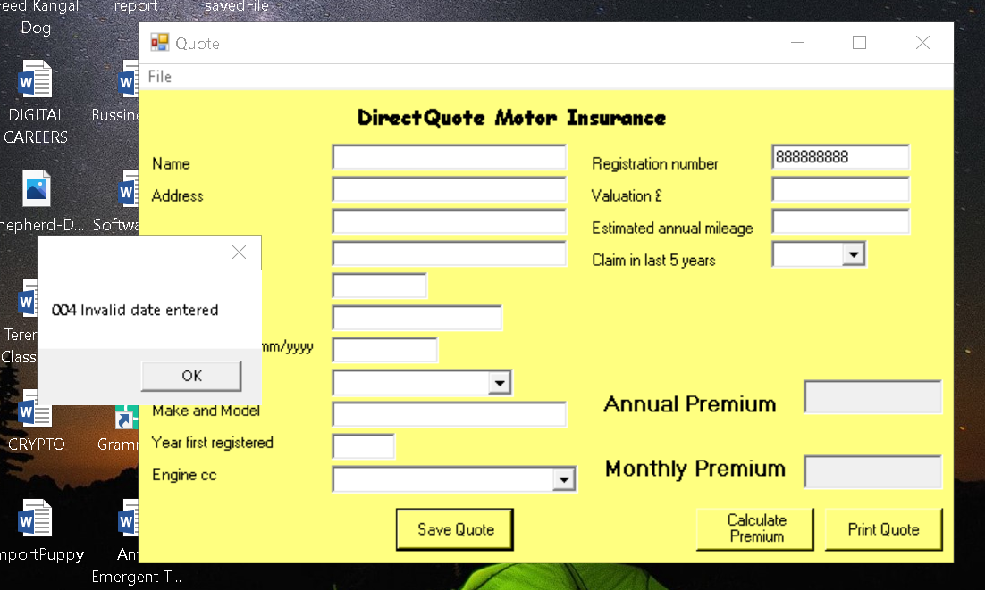1m.2
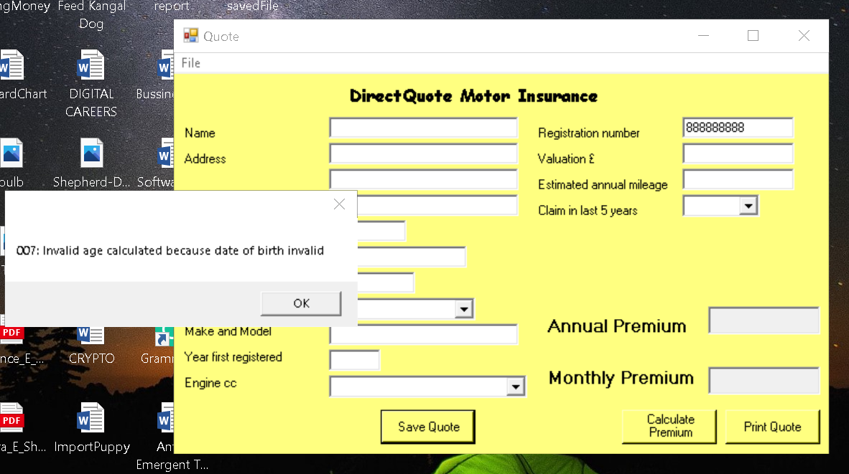1m.3

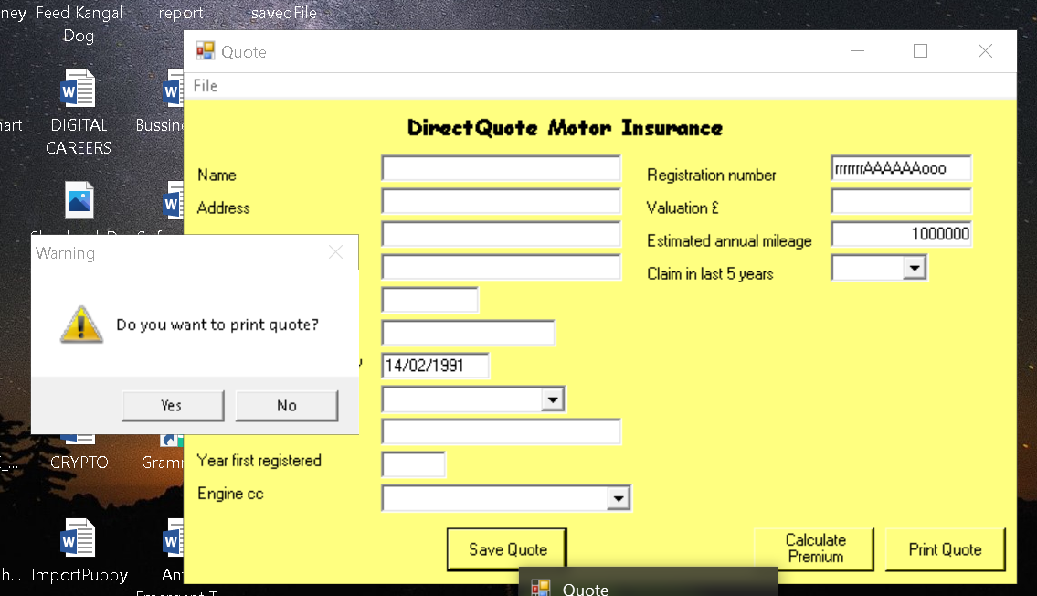1n.1
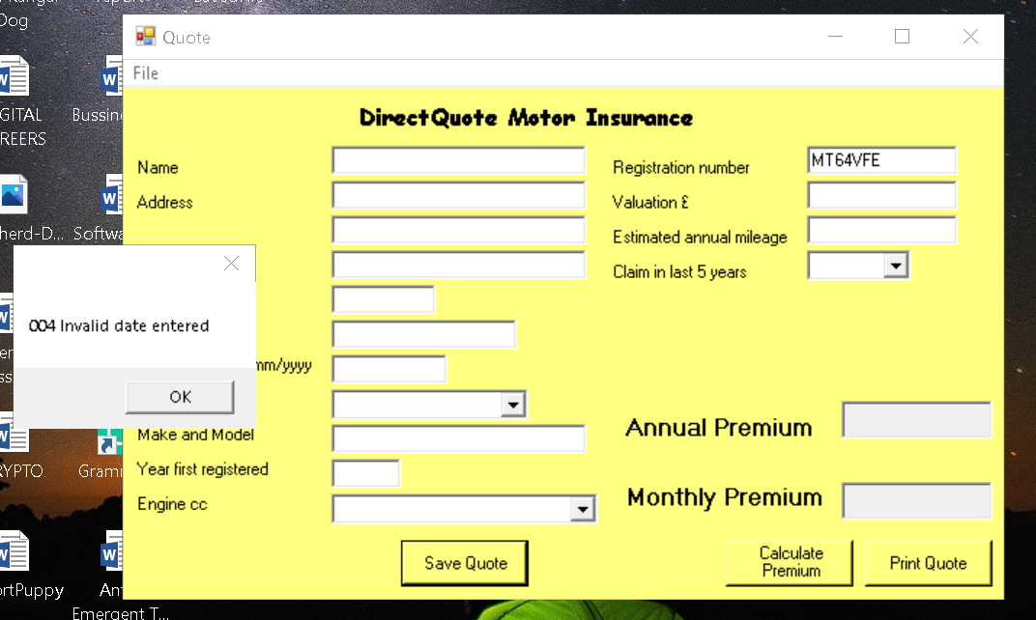1o.1

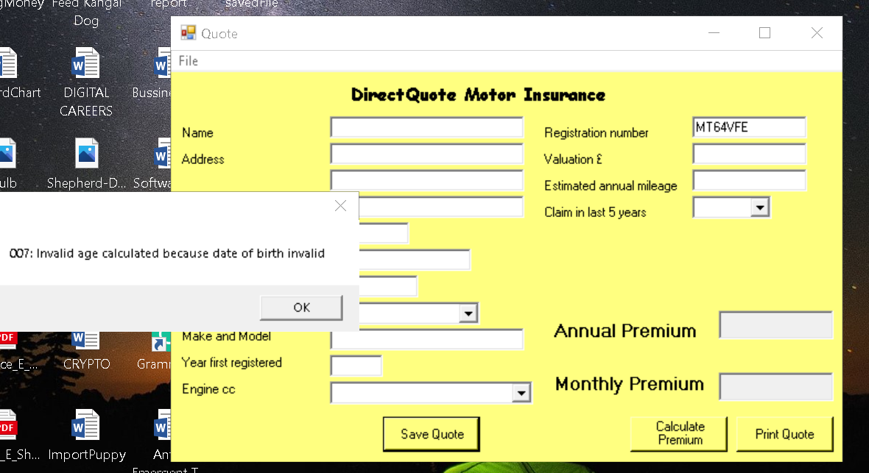1o.2

